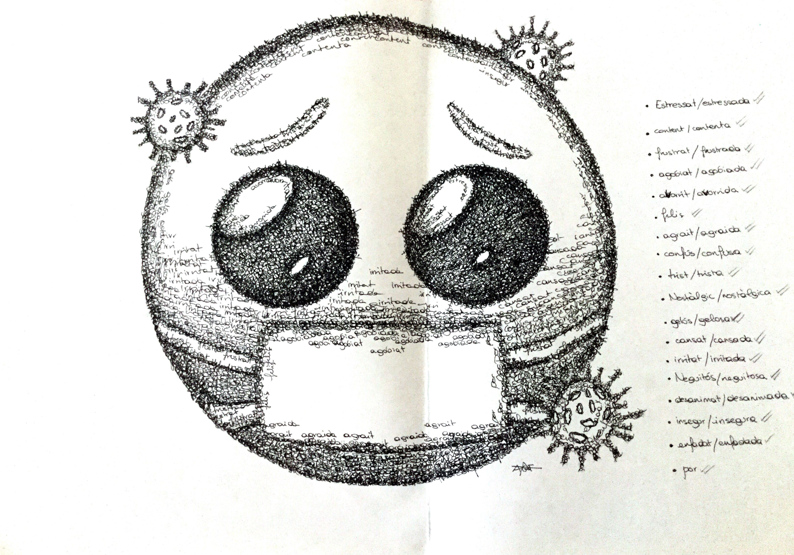
Ariadna Gadea (2nA)

